Answer of Final Examination of Software Engineering (B)
2004/06

Part 1 Selection (23marks)

- D, B
- B, A, D, C
- D
- A, B
- D, C, A, E, B
- C, D, A
- B, C
- B, D
- B
- B

Part 2 Filling (19 marks)

- Maintenance
- object-oriented
- ① corrective maintenance (or software repair)
② enhancement (or software update)
③ perfective maintenance
④ adaptive maintenance
- ① use-case modeling ② class modeling ③ dynamic modeling
- ①team leader ②team manager
- ①Requirement, ②Specification, ③Design, ④Implementation, ⑤Integration, ⑥Maintenance, ⑦ Retirement
- rapid prototype

Part 3 Judgment (8 marks)

- T
- T
- F
- F
- F
- F
- F
- F

Part 4 Case Analysis and Design (50 marks)

  - usecase diagram
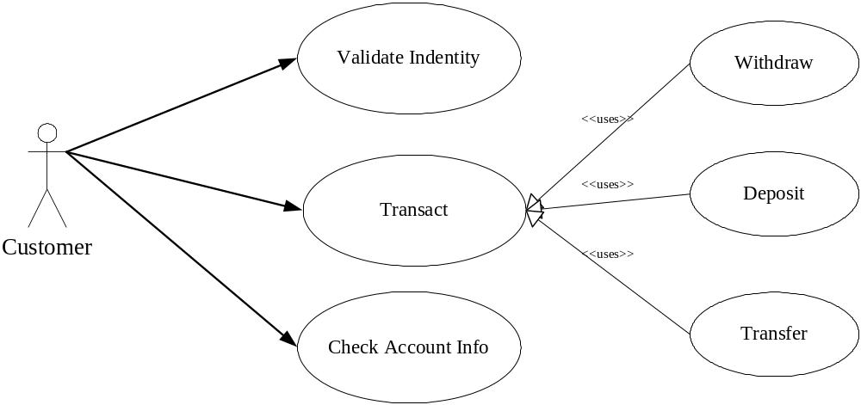

  - class diagram

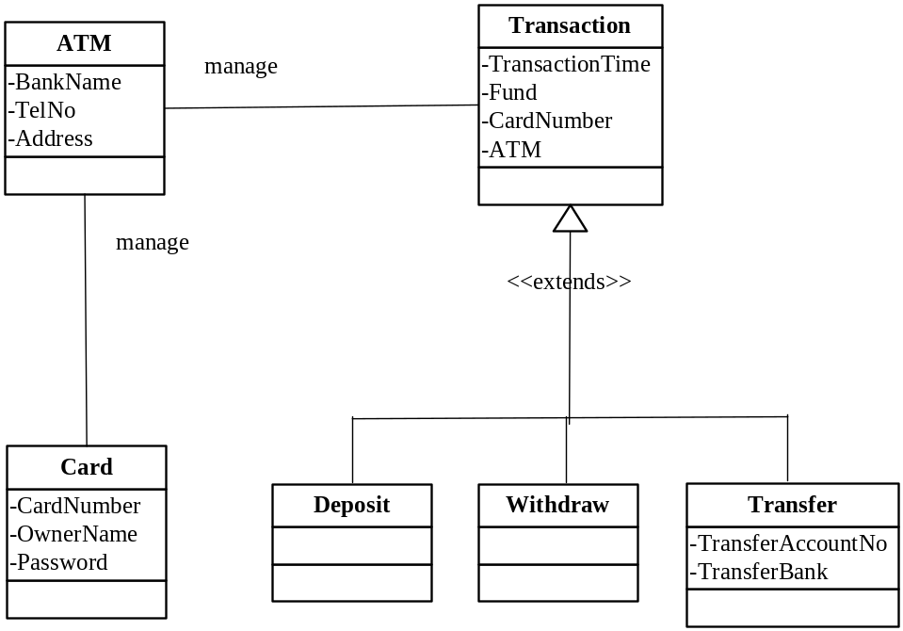

  - detailed class diagram
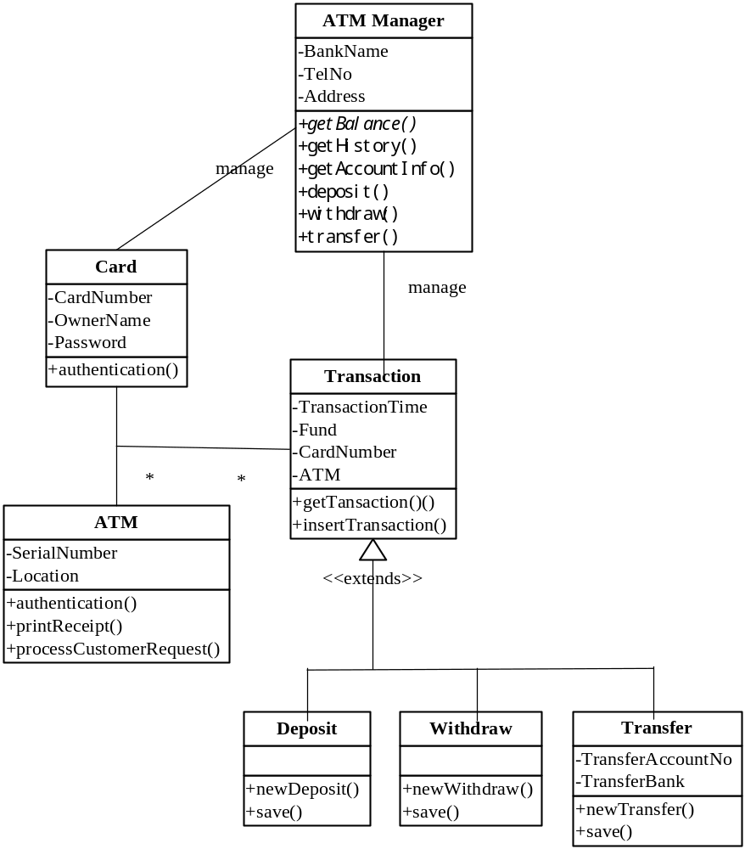

  - sequence diagram
